Jai Sidh Bhalla
https://www.facebook.com/share/r/17WNRng3wo/
The Straight-line news portal posted the interview of Jai Sidh Bhalla Congress on Facebook, wherein he stated that “Constitutional posts were considered highly significant, including positions like Chief Minister and Cabinet Ministers. Leaders such as Azad Sahib, though from the Bhaderwah region, were still regarded as representing Jammu, and he was even seen as the first Dogra Chief Minister. Over time, figures like Karan Singh also held important ministerial roles, showing that Jammu did receive representation. Individuals from areas like Banihal were likewise included in governance. The selection of leaders, such as a potential Chief Minister like Raman Bhalla, would have ultimately depended on the party high command. It was argued that representation should not be denied to Jammu, especially given its demographic strength. Drawing a comparison with India, where a small Sikh population produced a Prime Minister, it was believed that Jammu & Kashmir should have followed a merit-based approach. Decisions, therefore, should have been guided primarily by merit rather than other considerations”.
https://www.facebook.com/share/r/178vtvuFCd/
Jai Sidh Bhalla Congress posted on Facebook,” We will fight to restore the syllabus of Sir Syed Ahmad Khan and Iqbal, no matter how long it takes. We remained determined to bring back their teachings and ideas into the curriculum. Slogans were raised against injustice and misconduct, declaring that such behaviour would not be tolerated. The movement reflected a strong collective voice demanding respect for intellectual heritage and an end to wrongdoing.
https://www.facebook.com/share/v/1BfyeC1ibM/
The Straight line news portal posted the interview of Jai Sidh Bhalla Congress on Facebook,” The discussion emphasized that having multiple National Law Universities (NLU) in a state should not be an issue, as they contribute to regional development wherever they are established. It argued that while one NLU was proposed for Budgam in Kashmir, a similar institution should also be set up in Jammu to ensure balanced growth. Examples from other states like Maharashtra and Uttar Pradesh were cited, where multiple NLU exist without controversy. Hestressed that leaders should represent people rather than parties and must raise questions even if their own party is in power. There was also a broader point about unity, suggesting that Jammu, despite internal regional identities like Pir Panjal and Chenab, should collectively advocate for its rights. The conversation concluded that development demands, such as establishing an NLU, should be pursued through merit, dialogue, and constructive activism rather than division.
https://www.facebook.com/share/r/1BvQEofjox/
Jai Sidh Bhalla Congress Posted on Facebook,” He expressed strong frustration over not being heard by the university administration. He warned that if authorities refused to meet them, they would lock the Vice Chancellor’s office and other administrative offices in protest. He accused the administration of double standards—claiming that some groups could act aggressively without consequences, while others faced notices even for peaceful discussions. He highlighted incidents where students were threatened with actions like withholding degrees, which they strongly opposed. He also criticized the lack of response from the Vice Chancellor despite ongoing protests, calling it unfair and biased. He reflected anger against perceived injustice, unequal treatment, and a demand for accountability and dialogue from the university authorities.
https://www.facebook.com/reel/983796587547927/
Jai Sidh Bhalla Congress Posted on Facebook,” He strongly opposed the alleged involvement of RSS activities within the university, stating that Jammu University should remain an academic space, not a platform for political or ideological programs. He called on students to unite against such activities, declaring that RSS programs would not be allowed and even announcing the closure of the Physical Education Department gate as a form of protest. The speech criticized the administration, especially the Vice Chancellor, for allegedly permitting such events without accountability. It also highlighted concerns over the removal of figures like Iqbal and Sir Syed Ahmad Khan from the syllabus, portraying it as an attack on intellectual and cultural heritage. He pointed out what they saw as double standards, where certain groups faced no consequences while others were penalized.
https://www.facebook.com/share/r/1CZj8PXnkL/
Jai Sidh Bhalla Congress exposing jammu university in front of Ronak Khatri President Delhi University Students’ Union (2024-25) Posted on Facebook,” He warmly welcomed Ronak khatri and praised his presence at the university. He alleged that the university had become a hub of corruption, particularly highlighting a “revaluation scam” where students were initially failed and later passed after paying rechecking fees, sometimes with significant mark increases. He argued, mentally pressured students and raised serious questions about fairness. He urged Ronak Khatri to address this issue and support students in their struggle against administrative injustice. He expressed admiration for his courage in speaking against authorities and hoped to gain similar strength to fight for their rights. He also noted that various student organizations, regardless of political affiliation, extended support without conditions, showing collective trust in his leadership and intent to stand for students’ issues.
https://www.facebook.com/share/v/1AaJPNydrL/
Jai Sidh Bhalla Congress End education mafia end revaluation scam posted on Facebook,” He described their personal experience of alleged unfair evaluation in university exams. He said that despite writing detailed answers—filling many pages and even using extra sheets—they received the lowest marks in their batch. After filing an RTI, they discovered that several answers, including entire questions and extra sheets, were not checked at all across multiple subjects like Political Thought, BNSS, Family Law, and TPA. He expressed frustration that even significant portions of their answers were ignored, yet no action was taken against the evaluator, with authorities responding that a teacher’s judgment could not be challenged. He argued that this reflected a deeper systemic issue, where students are first failed, pushed into stress and self-doubt, and then later passed in revaluation with large increases in marks. He called this a form of corruption and mental harassment, claiming it forces students to pay revaluation fees under pressure. He also criticized the administration for lacking accountability, suggesting that internal priorities revolve around job security and promotions rather than student welfare. Concluding strongly, they announced plans to start a signature campaign and pursue legal action, aiming to expose and challenge what they described as a “revaluation mafia” and demand justice for affected students.
https://www.facebook.com/share/p/1BRXUjutjA/
Jai Sidh Bhalla Congress Posted on Facebook,” To vice chancellor JU. In 4th semester result i was given extremely low marks the lowest in the entire batch. It was shocking. I couldn’t believe it, so I filed an RTI. When I received the copies, in Political Thought, my extra continuous answer sheet was not checked at all, including a 16-mark and a 4-mark question. That was not all. In BNSS (4×4 marks), in TPA (4×2 marks), and in Family Law (4×2 marks), several of my answers were left unchecked. If answer sheets are not even checked properly, then what kind of evaluation system is this? Instead of correcting the mistake, the university asked me to pay ₹1100 for re-evaluation. And the response I received was shocking “There might have been a dispute at his home, or he might not have been in the mood to check the paper.” Is this the standard of academic responsibility? My last exam of 5th sem is on 9th march ( only 8 days left) Before that, 1. my answer sheet must be re-evaluated free of cost, 2. and action must be taken against the initial evaluator. If my result can be made public, then the truth about this education mafia can also be made public. If no action taken you will be given premature farewell and your entry will be declared as void. Legal stakeholder of Jammu university.
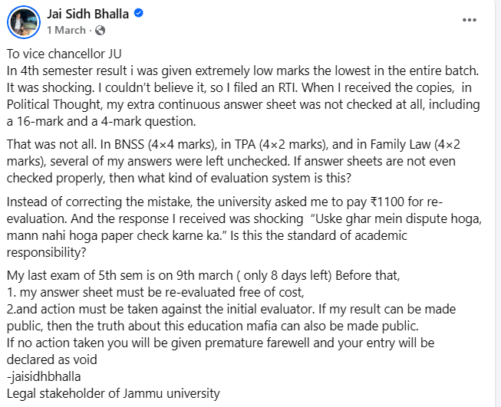

https://www.facebook.com/reel/2302665733546699/
Jai Sidh Bhalla Congress posted on Facebook,” The people who always shout “Dogra, Dogra, Dogra,” even Dogra journalists start their own channels—tell me, why didn’t they come here? Are these Dogras not fighting? Are we not fighting for our rights? Why didn’t a Dogra journalist come? Will Dogra journalists only work in Reasi? Children here were protesting, and if all the media had come, even one Dogra journalist should have come. Why didn’t they? Has their conscience been sold, or are they only getting paid by the government? We are protesting for ourselves, and we are asking questions from our own government too. So where are those so-called journalists sitting?
https://www.facebook.com/share/p/17otWsKtLS/
JK Channel news portal posted the media interaction of Jai Sidh Bhalla Congress on Facebook,” Why are we not allowed to protest, sir? Yesterday you said a protest would be held here and asked for a designated place, yet no officials came to supervise. Students come to exercise their right to protest, but the administration and police—especially women officers—are absent, preventing us from raising our voices. Everyone sees what is happening when authorities visit, yet we are not allowed to demonstrate. The right to protest is legal, and while you can speak freely, we are denied the same. The administration quietly continues its work while ignoring the students’ demand for accountability. Let us protest so that our concerns are seen and heard, and so everyone knows the true state of affairs.
https://www.facebook.com/reel/1956172874998649
Reformer Jammu news portal posted the media interaction of Jai Sidh Bhalla Congress on Facebook,” The students are protesting peacefully, but media and authorities, especially Dogra journalists and police, are absent despite their role in covering and supervising such events. Students face harassment while raising legitimate demands for multiple NLU, yet private interests and commercialization of public resources are prioritized over education. Land and facilities have been privatized, limiting access for students and depriving them of a proper learning environment. The administration ignores protests, blocks students, and mismanages resources, while everyone sees the injustice. The call is for equal treatment, transparency, and accountability, emphasizing that children’s right to education and lawful protest must be respected. The struggle is for justice, access, and the protection of public educational spaces in Jammu, ensuring that student voices are heard and their rights upheld.
https://www.facebook.com/share/p/19XGrrnhMz/
Jai Sidh Bhalla Congress on Facebook,” I strongly condemn the statement made by BJP LoP Sunil Sharma ji and Billawar MLA Satish Sharma ji claiming that the Pir Panjal region has made no sacrifices it ceases to exist. Such a remark is not only insensitive but also deeply ignorant of history and ground realities. By this flawed logic, even Jammu or Kashmir would cease to exist, because administratively and constitutionally we have a united map of Jammu & Kashmir, not separate maps for each region. Pir Panjal is a distinct geographical, cultural, and historical region that has endured decades of conflict, loss, and neglect. Denying its sacrifices is an insult to the people who have suffered, resisted, and contributed immensely to the social and political fabric of J&K. Geographical identity is not erased just because it exists within a larger administrative unit. Rejecting Pir Panjal’s representation reflects a poor understanding of geography, history, and federal sensibility.
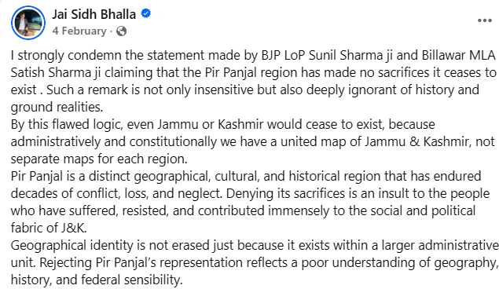

https://www.facebook.com/reel/1620126058996639/
Jai Sidh Bhalla Congress on Facebook,” He described that a professor had agreed to meet them inside the campus, but the administration stopped them at the gate. He alleged that the administration gave excuses, calling the area “terrorism-prone” and saying only students were allowed inside. He questioned this logic, pointing out that when an RSS rally with sticks was allowed, those participants were also not necessarily students. He argued that the university, funded by public money, should be accessible for addressing student issues and listening to their concerns. Blocking entry despite prior communication was termed unfair and contradictory. He accused the administration of double standards and high-handed behaviour, claiming that while some groups were allowed entry, others raising student issues were deliberately restricted.
https://www.facebook.com/share/p/18KoNr553g/
Jai Sidh Bhalla Congress on Facebook,” Crossroads of history, culture, and constitutional importance. If N in NLU truly stands for Nation, then Jammu undeniably deserves a National Law University—not just for itself, but for the country as a whole. An NLU in Jammu would not merely be an institution; it would be a bridge between regions, ideas, and opportunities for law students across India. Today, when we look at regional development, the imbalance is visible. Pir Panjal already has BGSBU. Jammu region hosts premier institutions like IIT, IIM, and AIIMS. But Chenab Valley stands forgotten—rich in talent, history, and strategic importance, yet deprived of any national- state level institution. No university Just aspirations waiting for recognition. Imagine a young student from Chenab Valley who dreams of becoming a constitutional lawyer or a judge of the Supreme Court. For them, distance is not just geographical—it is economic, social, and psychological. An NLU near Chenab Valley would transform lives, empower local youth, and integrate the region more deeply with the national academic framework. An NLU in Jammu would also strengthen constitutional values in a sensitive and diverse region, producing lawyers who understand federalism, minority rights, border issues, and national security—not from textbooks alone, but from lived reality. This is exactly what a “national” institution should do. Development is not charity; it is justice. If education is the strongest tool for nation-building, then denying Jammu a National Law University is denying the nation itself a chance to grow stronger, wiser, and more inclusive. Jammu deserves NLU. And through it, Chenab Valley deserves a future.
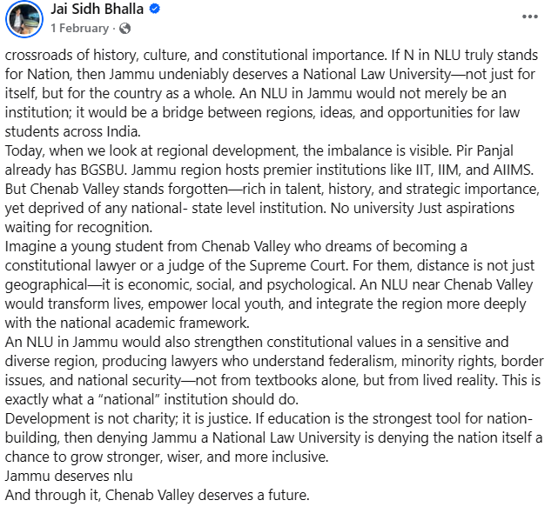

https://www.facebook.com/share/r/1b2CFWDpxk/
Jai Sidh Bhalla Congress on Facebook,” He strongly criticized the government, alleging that in Prayagraj, saints and sadhus were lathi-charged, dragged, and jailed, which they said was against religious values. He questioned how a government claiming to represent Sanatan Dharma could act against religious leaders and institutions like Shankaracharya. The administration justified its actions by citing public safety concerns, such as the risk of stampedes during gatherings. He pointed out an alleged double standard by referencing the 2022 Vaishno Devi stampede, claiming that no strict accountability followed and officials were instead promoted. They further mentioned an incident where a Shankaracharya figure, Mukteshwar Anand, tried to protect his disciples during the lathi charge and even challenged authorities to strike him instead.
https://www.facebook.com/reel/1268686308511199
Jai Sidh Bhalla Congress on Facebook,” He argued that laws should not be applied retrospectively—if a person received a seat based on merit under existing rules, it is unjust to cancel it later due to new policies. He emphasized that merit-based selection should remain the primary criterion, without being influenced by religion or politics. The comparison was made that if a student from Jammu secures a seat in Kashmir on merit, protests against them would feel equally unfair and discriminatory. He highlighted that demographic realities may naturally affect outcomes, but that does not invalidate merit. He also pointed out that if minority status or reservations were to be applied, they should follow proper legal procedures rather than arbitrary actions. He stressed fairness, consistency in law, and the importance of merit over communal or political considerations, warning against double standards and emotional reactions that undermine justice.
https://www.facebook.com/reel/881344574839746
Fair Voice News portal posted the interview of Jai Sidh Bhalla Congress on Facebook,” He raised several political and legal concerns, questioning leaders who talk about separating Jammu from Kashmir but do not bring any formal resolution in the assembly. Referring to Maharaja Hari Singh, he said his vision was of a united Jammu & Kashmir, and current debates should also focus on restoring statehood rather than division. He criticized the repeal of Article 370 and Article 35A, claiming that the region has been politically downgraded from statehood to a Union Territory. He also alleged double standards in political narratives, especially regarding issues like cow protection and regional identity. Highlighting merit-based education, they argued that cancelling seats obtained on merit is a violation of fair education principles, as guaranteed by B. R. Ambedkar’s constitutional framework. He further stated that if there were concerns about representation, authorities had the power to introduce policies like minority status or reservations but failed to do so. Instead, they claimed, issues are being given a communal angle. The real issues like employment, education, and statehood are being sidelined, while divisive politics is being used to polarize people, creating a gap between what leaders say and what they actually do.
https://www.facebook.com/share/p/1GggHgGeyQ/
Jai Sidh Bhalla Congress on Facebook,” There should be two National Law Universities (NLUs) in Jammu and Kashmir—one in Jammu and one in Kashmir. The Bar Council of India (BCI) permits multiple NLUs within a single state, provided they meet the required standards of infrastructure, faculty, and funding. For instance, Maharashtra already has two—one in Mumbai and another in Nagpur—serving different regions efficiently. Allocating an NLU only to Kashmir would not be a balanced or inclusive decision, as Jammu equally deserves access to premier legal education. Establishing one NLU in each region would ensure regional equity, better representation, and equal opportunities for students across the Union Territory.
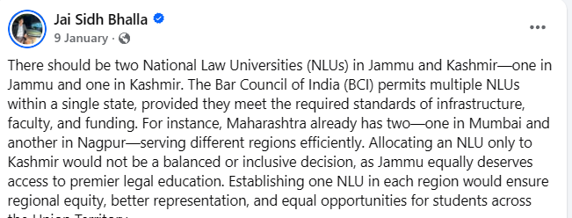

https://www.facebook.com/share/p/17rJAmfnKM/
Jai Sidh Bhalla Congress Posted on Facebook,” The hunger strike will continue until age relaxation is granted to JKAS aspirants and tomorrow’s exam is postponed.
https://www.facebook.com/share/p/1HLBvyfAoV/
Jai Sidh Bhalla Congress posted on Facebook,” The BJP knows only how to play politics. On one hand, they say that seats should be reserved for Hindus in SMVDU because the university runs on Hindu funds. By the same logic, Jammu University also runs on the money of the people of Jammu, so why are outsiders being allowed to apply under reserved categories there? Moreover, the Chancellors of both universities are associated with the BJP.
https://x.com/TheDograguy_/status/2004581253937553496?s=20
Jai Sidh Bhalla Youth president of congress posted on X,” How was an RSS rally allowed on the secular campus of Jammu University? Did they have permission? And who was the official who granted them permission? on what grounds? I had asked for the answer to this question through RTI three months ago than filed first appeal.
https://www.facebook.com/share/v/1DwLfnvMwC/
Jai Sidh Bhalla Youth president of congress posted on Facebook,” He highlighted the worsening situation in Jammu & Kashmir after the removal of Article 370, especially for JKSSB aspirants who were promised age relaxation but did not receive it. As a result, students were forced to go on hunger strike, while authorities passed responsibility between the Chief Minister and the Governor. The age limit, which was earlier around 37 years, was reduced to 32, unlike other states where it is higher, creating a sense of injustice. The speaker argued that students are suffering due to unclear governance and lack of accountability, with bureaucracy dominating decision-making. He also claimed that local candidates are being overlooked while outsiders are being appointed to key positions like Vice Chancellors. Economic losses, unemployment, and restrictions on protests have further worsened conditions, with students even being threatened with notices and degree cancellation.
https://www.facebook.com/share/p/1BUxNXahjB/?mibextid=6aamW6
Jai Sidh Bhalla JK youth congress state secretary Posted on Facebook,” Some people are calling the SMVDU Shrine Board Medical College "anti-Hindu" just because 42 seats went to Muslims, 7 to Hindus, and 1 to Sikhs. This logic is absurd, as admissions are based on NEET merit, not religion. Since J&K’s population is over 70% Muslim, naturally more Muslim candidates will qualify on merit; the presence of an extra seven seats is not a point for blaming the elected government, given that the LG is the Chairman of the Medical College. True injustice would only occur if a meritorious Hindu candidate with a higher NEET rank was denied admission, but that is not the case here. In J&K, there is no religion-based reservation, making this entire narrative a communal trap clearly timed to polarize voters in the Nagrota by-election. Ultimately, merit doesn’t have religion—propaganda does.
https://www.facebook.com/share/p/19qzxYCa8n/
Jai Sidh Bhalla JK youth congress state secretary Posted on Facebook,” Harsh Dev managed to secure more votes than the NC DDC candidate in both 2024 and 2025 in Nagrota, despite being an outsider and not belonging to the constituency, and even after NC’s deducted its 11000 votes — a truly appreciable performance. Meanwhile, BJP’s votes dropped from 48,000 to 42,000, and its vote share fell from 65% to 57%, despite sympathy and liquor-distribution factors. The decline in BJP’s vote base will continue.
https://www.facebook.com/share/v/1BK96TViVJ/
Fair Voice News portal posted the media interaction of Jai Sidh Bhalla Congress on Facebook. He said that two criminal cases were filed against him during his early political activism, including one at the age of 18 after confronting the Hon’ble Home Minister and another at 19 for burning an effigy of Hon’ble MLA Vikram Randhawa. He claimed these cases were attempts to suppress dissent but stated that he was not afraid and would continue his political struggle. He accused the BJP government of misusing police and administration to silence opposition voices and also alleged partisan behaviour in institutions, citing a protest at Jammu University. He further expressed confidence that Congress and its allies would form governments in India and Jammu & Kashmir in the future, especially with support from regions like Chenab and Doda. He also criticised the NC government for inaction on public issues and highlighted concerns like unemployment, drug abuse, and lack of educational infrastructure, particularly in Chenab and Pir Panjal. He concluded that despite political ups and downs, his opposition to the BJP and his political struggle would continue.

